INSTRUCTIONS TO Use Apollo:

The web instance of Apollo is running at http://162.243.149.53:8887

Apollo User Guide: http://genomearchitect.github.io/users-guide

TANVEER ANWAR SALIM chr8 700,001 795,000 MCGJ.8.6 MCGJ.8.6

LOGIN INFORMATION APOLLO

----------------------------------

INSTRUCTIONS:

1. Be sure the right of your genetic engine says

"Valley Oak"

2. Paste chr8 700,001 795,000 into the Annotator search

engine http://162.243.149.53:8887/annotator/index

and enter "Go".

3. Choose one of the genes in the "Annotations"

section to your right. CLICK "Go to Annotation"

4. Find the purple bars that look like this:

NCBI BLAST: Click on "PROTEIN BLAST"

The web instance of Apollo is running at http://162.243.149.53:8887

Apollo User Guide: http://genomearchitect.github.io/users-guide

TANVEER ANWAR SALIM chr8 700,001 795,000 MCGJ.8.6 MCGJ.8.6

LOGIN INFORMATION APOLLO

----------------------------------

INSTRUCTIONS:

1. Be sure the right of your genetic engine says

"Valley Oak"

2. Paste chr8 700,001 795,000 into the Annotator search

engine http://162.243.149.53:8887/annotator/index

and enter "Go".

3. Choose one of the genes in the "Annotations"

section to your right. CLICK "Go to Annotation"

4. Find the purple bars that look like this:

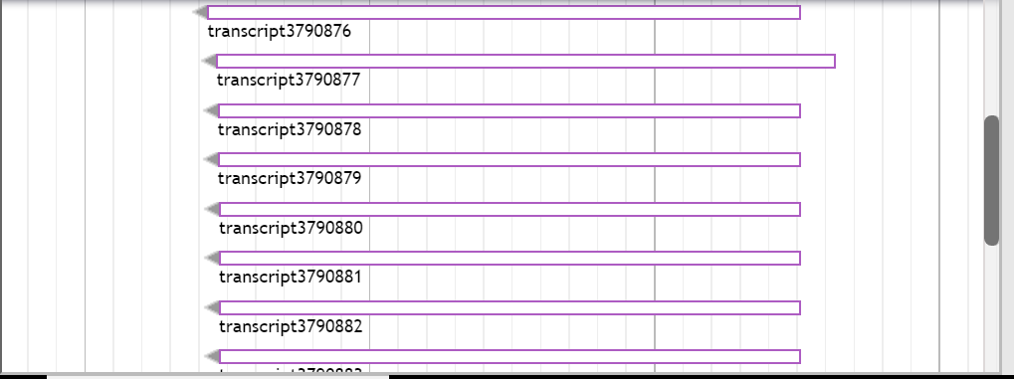

Drag ONE to the top:

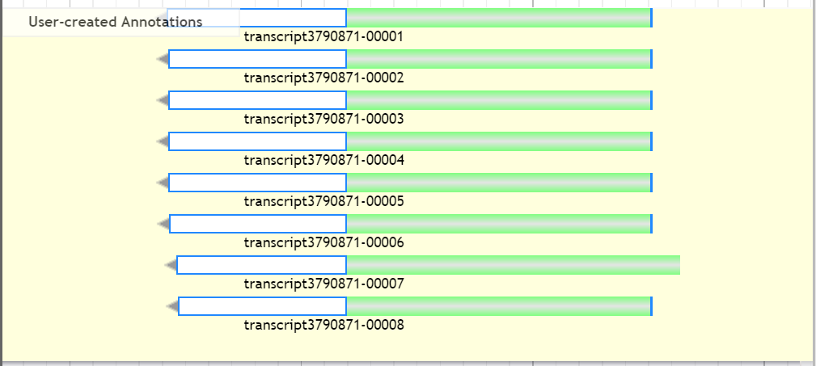

Highlight ONLY ONE OF THEM like this:



Right click on that highlighted and click “Get Sequence”

Make sure “Peptide Sequence” is highlighted

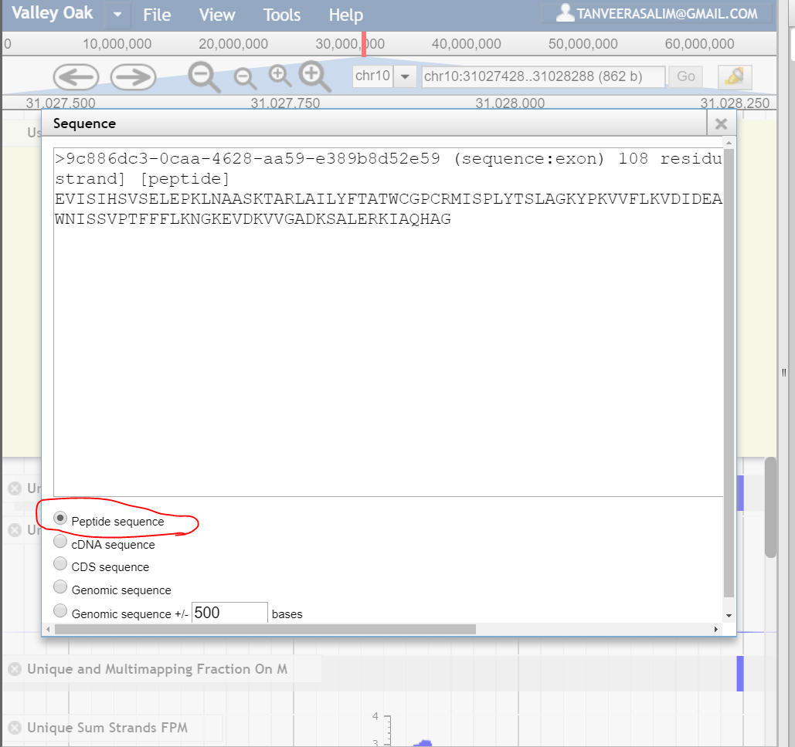

Copy EVERYTHING IN “Sequence” and paste that into the NCBI Peptide Blast.

To get to NCBI Peptide Blast:

1. Go to <https://blast.ncbi.nlm.nih.gov/Blast.cgi>

Click what is Below:

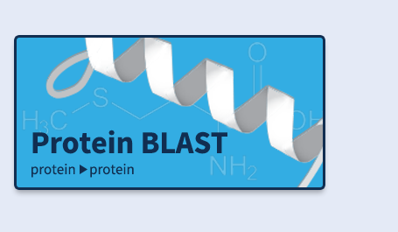

And paste it into the following box. MAKE SURE “blastp” is HIGHLIGHTED BEFORE YOU PASTE:

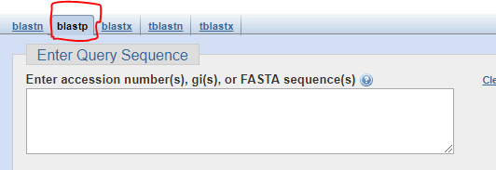

So now it looks like this:

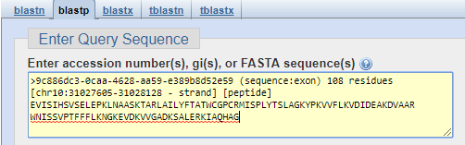

Now CLICK:



Copy the URL and write it down in MCDB 187AL Annotated Sequences List.

Find sequence homologs by copying and pasting the FASTA Sequence:

That’s this:



And paste it to BLAST to find protein sequence homologs.

Scroll down to **Sequences producing significant alignments:**

Click on the Sequence ID of one of the homologs.

Click on FASTA

Copy that Sequence HOMOLOG to Clustal Omega

Paste those BLAST homologs (FASTA) to Clustal Omega to find more homologs.

You can use the phylogenetic tree feature to confirm your inferences of homologs

And the evolutionary relationship between species ( Ex: Is it reasonable to conclude

That this species descended from this ancestral species. ). Record your inferences and

Download the Multiple Sequences Alignment page Data. You will use that in your research

Paper. Store it in Dropbox.

Structural Modeling:

Save the page.

Used to infer functionality of peptide sequences based on localization of peptide sequences?

Finish doing this to ALL OTHER GENES on the Annotations Page. You have plenty left:

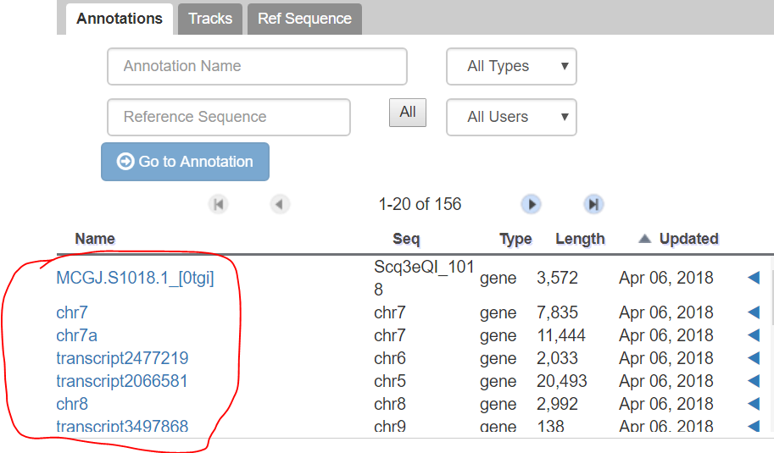

What should we present for MCDB 187AL Presentation Week 3

<https://blast.ncbi.nlm.nih.gov/Blast.cgi#alnHdr_1343964718>